Basic Characteristics of Printable Large-Area Electrostatic Tactile

【Summary】：

We have developed a large printable electrostatic tactile display based on electrostatic tactile and paper electronics technology. In this display, it is possible to impart tactile sensation to a specific part of a symbol alone by printing a color ink for that symbol on the electrode. The use of a paper medium makes the display easy to enlarge and develop at low cost and it can be rolled up, miniaturized and carried easily. In addition,the paper investigated the possibility of this display's uniform tactile presentation over a large area, and the effect of the colored ink layer on perceived intensity.

【Device】：

The configuration used for the printable electrostatic tactile display developed in this work is shown in Fig. 1. In this display, we printed silver nano-ink [12] (Mitsubishi Paper Mills Co., Ltd., Tokyo, Japan; NBSIJ-MU 01, volume resistivity of <1.0×1010−5 Ω∙cm) on a white polyethylene terephthalate (PET) film that is used as a mount for electrode preparation. This silver nano-ink is used as an electrode. On the upper layer of the electrode, a white background ink that acts as a base for printing of symbols was coated over the entire surface. This white background ink covers the electrode pattern.

Then, on the upper surface of this layer, the actual color printing ink that forms the main body of the pattern was printed. By matching and overlapping the shape of the electrode with that of the pattern, it is possible to impart tactile sensation to a specific part of a symbol only. A transparent PET film was attached to the top layer to provide insulation and surface protection.

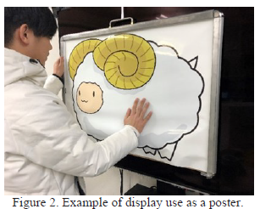 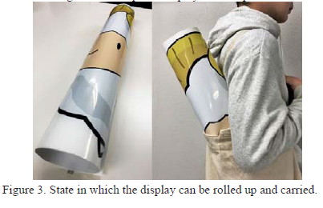

【Experiments】：

**E1：EFFECT OF VOLTAGE DROP DUE TO DISPLAY UPSIZING**

**Purpose:** The problem of large-scale displays is the uneven distribution of electrostatic forces. Therefore, measure the voltage drop across the display to verify if there are differences affecting the perceived intensity at each point.

**Procedure：**In these experiments, we used a uniformly printed silver nano-ink over the entire A3 (297×420 mm) mount (Card Hi Tester 3244–60, HIOKI). We measured a total of 77 points that moved vertically and horizontally by a distance of 4 cm from the wire connector.

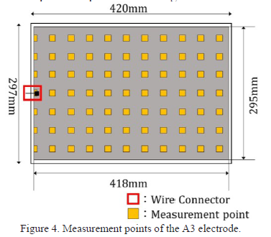

**Results：**

Using Ohm's law, it was found that the maximum voltage drop across the electrode layer of the display was 0.18 mV. When electrostatic haptic presentation is actually performed, and because a voltage of several hundred volts is applied to the display, this voltage drop value represents an error of only 0.0001% or less of the input voltage and the users cannot seem to perceive it. Therefore, it can be confirmed that the voltage drop at the electrode layer has no influence on this display.

**E2：PERCEPTIBLE LOWER LIMIT VOLTAGES OF DISPLAYS WITH DIFFERENT INSULATING LAYER THICKNESSES**

**Purpose:** By investigating the lower voltage limit at which the electrostatic force can be perceived in the state in which the symbol is printed on the electrode, the minimum applied voltage required for the proposed display can be verified.

**E3：MEASUREMENT OF RELATIONSHIP BETWEEN APPLIED VOLTAGE AND PERCEIVED INTENSITY FOR EACH DISPLAY WITH DIFFERENT INSULATING LAYER THICKNESSES**

**Purpose:** There is a possibility that the insulating layer thickness affects the relationship between the applied voltage and the perceptual intensity. Therefore, we investigated the perceptual intensity transition when the applied voltage was increased with respect to the three displays in Fig. 6.

**E4：COMPARISON OF PERCEIVED INTENSITY BETWEEN DISPLAYS UNDER CONSTANT VOLTAGE VALUE CONDITION**

**Purpose:** In response to the results of Experiment 3, the perceived intensity difference between the three displays generated when 360 V (the reference voltage of Experiment 3) was applied was verified, and the relative difference in perceived intensity based on the applied voltage fluctuation was obtained.

【Contribute】:

We have developed a large printable electrostatic haptic display using electrostatic tactile and paper electronics technology. In this display, it is possible to impart tactile sensation to only a specific part of a symbol by printing a color ink for a symbol on the electrode. Use of the paper medium makes the display easy to enlarge and develop at low cost and it can be rolled up, miniaturized and carried easily.

【Future work】：

In future study, we will measure the permittivities of the insulation layers of BD and MD. From the results, we will estimate the electrostatic attraction force and design the texture information for the electrostatic tactile sensation more accurately. In addition, by emphasizing the contours of the touched symbol, we will establish a method to present the shape more clearly to the user and aim for actual use as a poster.